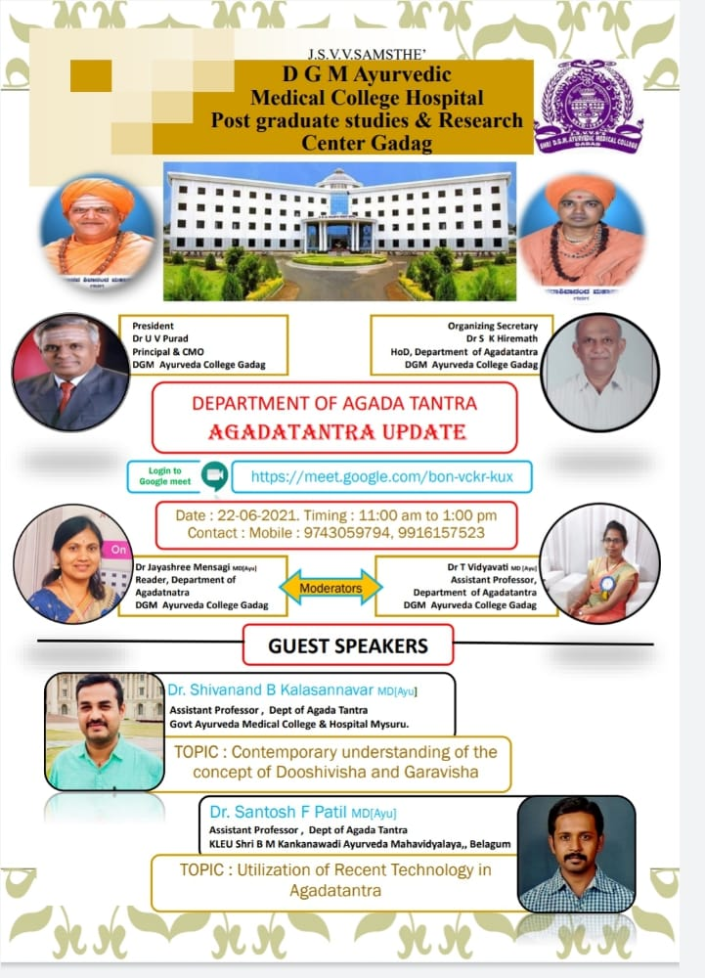The department of AGADA TANTA has organized a Webinar on Date-22-06-2021 at 11am TO 01:00pm on “AGADATANTRA UPDATES” with a targeted group III BAMS, Interns, Post graduate students, Alumni, Institution Faculty of our college and Students and teaching faculty of various colleges.
The expert resource person- DR. SHIVANAND PATIL (Kalasannavar), Assistant Professor Dept of Agada Tantra Govt Ayurveda Medical College & Hospital, Mysuru. And Dr.Santosh F Patil. Assistant Professor and Research Associate Central Research Laboratory KAHER’s Shri B M K Ayurveda Mahavidyalaya, PG Studies and Medical Research Center, Belagavi, shared their valuable clinical experience on aspirants.
AIM and OBJECTIVES of WEBINAR
AIM:
To make students to understand about the concept of Garavisha and Dooshivisha with present scenario, Agada Tantra Updates and its clinical approach.
OBJECTIVES:
At the end of this webinar each participant should be able to,
1. KNOW, about the present scenario food style and its harmful effects on body.
2. OUTLINE, concept of Garavisha and Dooshivisha with present scenario and toxicogenomics.
3. COMPOSE, basic treatment for Garavisha and Dooshivisha identifications of toxins presents in Mahavisha and Upavisha.
4. DRAW, the limitations of Toxicgenomics in understanding the diagnosing aspects of Garavisha and Dooshivisha

PROGRAM
Organising secretary: Dr. S.K.Hiremath , professor and HOD, Department of Agada Tantra, DGMAMC Gadag
Program Moderators: Dr. Jayalaxmi Menaagi , Associates professor, DGMAMC Gadag and Dr. T.Vidyavati , Assistant Professor, DGMAMC Gadag
- Program started with lord Dhanvantari sthavana by 3rd year student Miss Pooja Siroor
- Welcome speech by Dr. S.K.Hiremath professor Department of Agada Tantra
- Inauguration by Principal Dr. U.V Purad.
- Expert Resource Person Speech by
DR. SHIVANAND PATIL
Sir has explained all aspects related to the concept of Garavisha and Dooshivisha, their contemporary significance. And given insight information about How to diagnose and treat Dooshivisha and Garavisha.
DR .SANTOSH F PATIL
Sir has explained about technology can provide credentials fingerprints of visha dravya and Agadas by understanding of shodhana method and changes in them by fingerprintings. Sir has given ideas about systemic toxicity and its correlation in Ayurveda. And how to use Morden technology to prove Ayurveda concept of Vishapareeksha.
- The session was ended with vote of thanks by Dr. S.K.Hiremath Professor and HOD Dept. of Agada Tantra DGMAMC Gadag. All third year students and faculty members scholars, interns get benefitted by this session.

